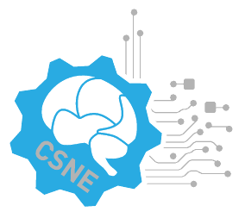A.

**NSF Engineering Research Center**

**for Sensorimotor Neural Engineering**

**http://www.csne-erc.org**

**CSNE Annual Review Site Visit Schedule**

**May 7-9, 2013**

**Tuesday, May 7**

Location: Watertown Hotel, 4242 Roosevelt Way NE, Seattle, WA

PRE-REVIEW Orientation and briefing of site visit team by NSF

**Wednesday, May 8**

Location: CSNE Headquarters, 204 Russell Hall, 1414 NE 42nd St., Seattle, WA

7:30-8:00 Breakfast All

8:00-8:05 Site Visit Team Introductions Tom Daniel, CSNE Interim Director

8:05-9:00 Overview of the Center Tom Daniel, CSNE Interim Director

9:00-10:00 Research Program by Testbed (15 min + 5 min discussion each)

9:00-9:20 Neuro-rehabilitation Systems: Moritz/Ozturk

9:20-9:40 Closed-loop Prosthetic Limbs: Hannaford/Moon

9:40-10:00 Closed-loop Brain-Controlled Interface: Rao/Kassegne

10:00-10:15 Coffee Break

10:15-11:15 Research Program by Thrust (15 min + 5 min discussion each)

10:15-10:35 Reverse and Forward Engineering: Fairhall/Rieke

10:35-10:55 Control and Adaptation: Chizeck/Tedrake

10:55-11:15 Communication and Interface: Smith/Kassegne

11:15-12:00 Executive Session #1 Site Visit Review Team / NSF Staff

12:00-12:30 Lunch

12:30-1:30 Poster Session and Demos

1:30-2:15 Industrial/Practitioner Collaboration/Technology Transfer/Innovation: Roberts

2:15-3:15 Private Meeting with Industry

3:15-4:15 University and Pre-college Education and Diversity (Education/Diversity Team)

4:15-5:00 Private Meeting with ERC Students:

5:00 – 6:00 Executive Session #2

6:00 – 6:15 Site Visitors Provide Questions to ERC

6:15 - Evening Work for the Site Visit Team and the ERC on the First Day